# List Methods - Python Exercise

Below is the image provided along with the recreated question, terminal output, and answer:

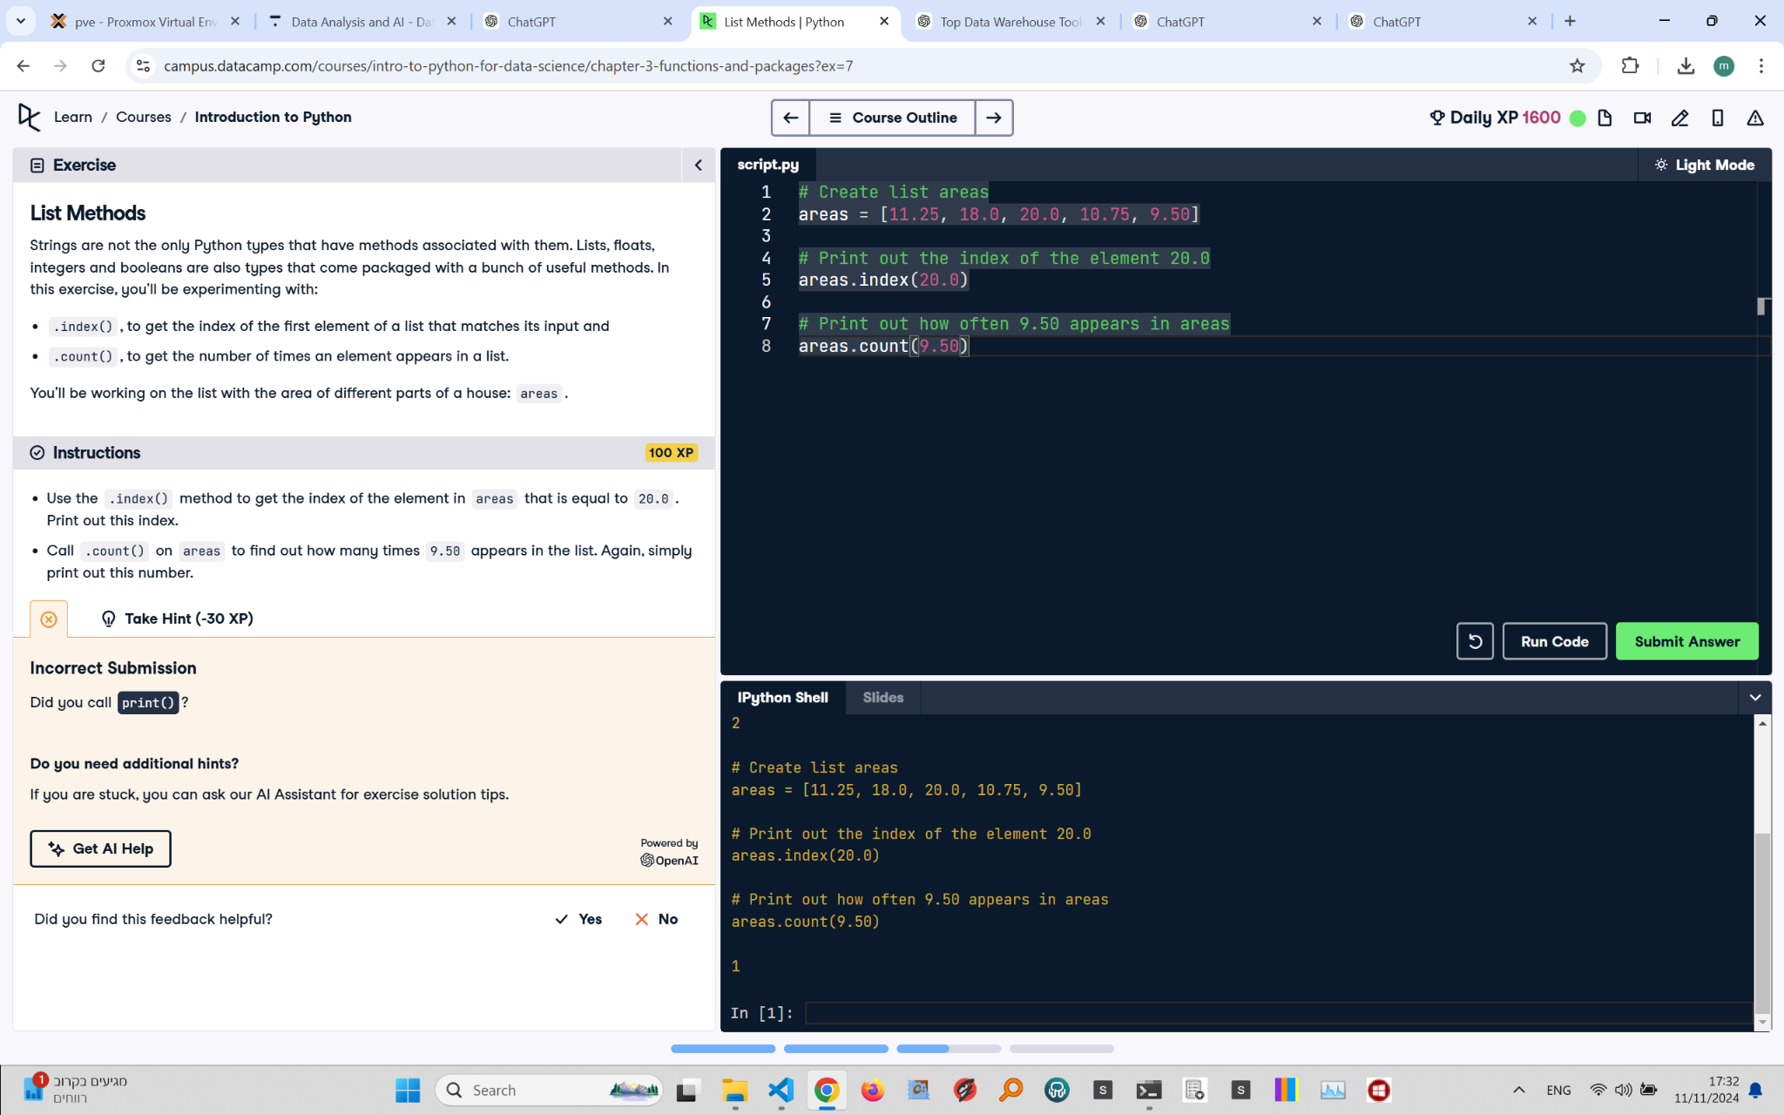

## Recreated Question and Terminal

List Methods  
Strings are not the only Python types that have methods associated with them. Lists, floats, integers, and booleans are also types that come packaged with a bunch of useful methods. In this exercise, you'll be experimenting with:

- .index(), to get the index of the first element of a list that matches its input  
- .count(), to get the number of times an element appears in a list.  
  
You'll be working on the list with the area of different parts of a house: areas.

Instructions:  
- Use the .index() method to get the index of the element in areas that is equal to 20.0. Print out this index.  
- Call .count() on areas to find out how many times 9.50 appears in the list. Again, simply print out this number.

## Answer

# Create list areas  
areas = [11.25, 18.0, 20.0, 10.75, 9.50]  
  
# Print out the index of the element 20.0  
print(areas.index(20.0))  
  
# Print out how often 9.50 appears in areas  
print(areas.count(9.50))

## Explanation of the Answer

The .index() method finds the index of the first occurrence of 20.0 in the list areas, which is 2. The .count() method counts how many times 9.50 appears in the list, which is 1. The print() function is used to display both results.